1. What is Selenium?

Ans. Selenium is a robust test automation suite that is used for automating web-based applications. It supports multiple browsers, programming language and platforms.

1. What are different forms of Selenium?

Ans. Selenium comes in four forms-

* Selenium WebDriver – Selenium WebDriver is used to automate web application using browser’s native methods.
* Selenium IDE – A Firefox plugin that works on record and play back principle.
* Selenium RC – Selenium Remote Control (RC) is officially deprecated by the selenium, and it used to work on JavaScript to automate the web application.
* Selenium Grid – Allows selenium test to run in parallel across multiple browsers.

1. What is some advantage of Selenium?

* Selenium is open source and free to use without any license cost.
* It supports multiple language like java, ruby, python etc.
* It supports multi browser testing.
* It has good number of resources and helping community over the internet.
* Using selenium IDE component, non-programmers can also write automation scripts.
* Using selenium grid component, distributed testing can be carried out on remote machines possible.

1. What is some limitation of Selenium?

* We cannot test desktop application using selenium.
* We cannot test web services using selenium.
* For creating robust scripts in selenium web driver. Programming language knowledge required.
* We must rely on external libraries and tools for performing tasks like – logging(log4J), testing framework (testNG, Junit), reading from external files (POI for excels) etc.

1. Which all browser/driver are supported by selenium WebDriver?

Ans. Some commonly used browsers supported by selenium are –

Google Chrome – ChromeDriver

Firefox – FireFoxDriver

Internet Explorer – InternetExplorerDriver

Safari – SafariDriver

HtmlUnit (Headless browser) – HtmlUnitDriver

Android – Selendroid / Appium

IOS – ios-driver / Appium

1. Can we Test APIs or web services using selenium WebDriver?

Ans. No selenium webdriver uses browser’s native language to automate the web application. Since web services are headless, so we cannot automate web services using selenium webdriver.

1. What are testing type supported by selenium WebDriver?

Ans. Selenium webdriver can be used for performing automated functional and regression testing.

1. What are the various ways of locating an element in selenium?

Ans. The different locators in selenium are –

* ID
* XPath
* cssSelector
* className
* tagname
* name
* linkText
* partialLinkText

1. What is an XPath?

Ans. XPath or XML path is query language for selecting nodes fromXML documents. XPath is one of the locators supported by selenium webdriver.

1. What is absolute XPath?

Ans. An absolute XPath is a way of locating an element using an XML expression beginning from root node i.e. htmlnode in case of web pages. The main disadvantage of absolute xpath is that even with slightest change in the UI or any element the whole absolute XPath fails.

Example – html/body/div/div[2]/div/div/div/div[1]/div/input

1. What is relative XPath?

Ans. A relative XPath is a way of locating an element using an XML expression beginning from anywhere in the HTML document. There are different ways of creating relative XPath which are used for creating robust XPaths (unaffected by changes in other UI elements).

Example - //input[@id=’username’]

1. What is the difference between single slash (/) and double slash (//) in XPath?

Ans. In XPath a single slash is used for creating absolute paths beginning from root node

* Whereas double slash is used for creating relative XPaths.

1. Which XPath you will prefer to use? Why?

* Normally we prefer to use Relative XPath.
* Relative XPath can identify element even though some UI changes happened but can’t identify by Absolute XPath.

1. What is the difference between Absolute XPath and Relative XPath?

* Absolute XPath will traverse entire HTML from the root node / html.
* Relative XPath directly jump to node based on attribute specified.

1. How can we inspect the web element attributes to use them in different locators?

Ans. Using Chropath or developer tool we can inspect the specific web elements.

Chropath is a plugin that provides xpath and CSS Selectors. From automation perspective, “Right click on page inspect element” is used specially for inspecting web-elements in order to use their attribute like id, class, name etc. in different locators.

1. How can we locate an element by only partially matching its attributes value in Xpath?

Ans. Using contains method we can locate an element by partially matching where the attributes have dynamic values with certain constant part.

xPath expression = //*[contains(@name,’user’)]

//*[contains(text(),’abc’)]

* The above statement will match the all the values of name attribute containing the word ‘user’ in them.

1. How can we locate elements using their text in XPath?

Ans. Using the text() method.

XPath expression - //*[text()=’username’]

1. How can we move to nth child element using XPath?

Ans. There are two ways of navigating to the nth element using XPath –

* Using square bracket with index position

Example – div[2] will find the second div element

* Using position() –

Example – div[position()=3] will find the 3rd div element.

1. What is the syntax of finding elements by class using CSS Selector?

Ans. By .className we can select all the element belonging to a particular class e.g. ‘.inputtext’ will select all elements having class ‘inputtext’.

1. What is the syntax of finding elements by id using CSS Selector?

Ans. By #idValue we can select all the element belonging to a particular id e.g. ‘#u_0_n’ will select all elements having id ‘u_0_n’.

1. How can we select elements by their attribute value using CSS Selector?

Ans. Using [attribute=value] we can select all the element belonging to a particular attribute e.g. ‘[type=radio]’ will select the element having attribute type of value ‘radio’.

1. What is fundamental difference between XPath and CSS selector?

Ans. The fundamental difference between XPath and CSS selector is using XPath we can traverse up in the document i.e. we can move to parent elements. Whereas using CSS Selector we can only move downwards in the document.

1. How can we launch different browsers in selenium webdriver?

Ans. By creating an instance of driver of a particular driver.

WebDriver driver = new ChromeDriver().

1. What is the use of driver.get("URL") and driver.navigate().to("URL") command? Is there any difference between the two?

Ans. Both driver.get(“URL”) and driver.navigate().to(“URL”) commands are used to navigate to a URL based as parameter.

get() is used to navigate particular URL(website) and wait till page load. driver. navigate() is used to navigate to particular URL and does not wait to page load.

1. How can we type text in a textbox element using selenium?

WebElement searchTextBox = driver.findElement(By.id(“search”));

searchTextBox.sendKeys(“searchItem”);

1. How can we clear a text written in a textbox?

Ans. Using clear() method we can delete the text written in a textbox.

driver.findElement(By.id(“elementLocator”)).clear();

1. How to check a checkbox in Selenium?

Ans. The same click() method used for clicking buttons or radio buttons can be used for checking checkbox as well as.

1. How can we submit a form in Selenium?

Ans. Using submit() method we can submit a form in selenium.

driver.findElement(By.id(“form1”).submit();

* Also, the click() method can be used for the same purpose.

1. Explain the difference between close and quit command.

Ans. Driver.Close() - Used to close the current browser having focus.

driver.quit() – Used to close the all the browser instance.

1. How to switch between multiple windows in selenium?

Ans. Selenium has driver.getWindowHandles() and driver.switchTo().window(“{windowHandleName”) command to work with multiple windows.

* The getWindowHandle() command returns a list of ids corresponding to each window and on passing a particular window handle to driver.switchTo().window(“{windowHandleName}”) command we can switch control focus to that particular window.

For(String windowHandle:driver.getWindowHandles()) {

driver.switchTo().window(handle);

}

1. What is the difference between driver.getWindowHandle() and driver.getWindowHandles() in selenium?

Ans. driver.getWindowHandle() return a handle of the current page (a unique identifier)

Whereas driver.getWindowHandles() return a set of handles of the all the pages available.

1. How can we move to a particular frame in selenium?

Ans. The driver.switchTo() commands can be used for switching to frames.

driver.switchTo().frame(“{frameIndex/frameId?frameName}”);

* For locating a frame we can either use the index (starting from 0), its name or Id.

1. Can we move back and forward in browser using selenium?

Ans. Yes, using driver.navigate().back() and driver.navigate().forward() commands we can move backward and forward in a browser.

1. Is there a way to refresh browser using selenium?

Ans. There a multiple way to refresh a page in selenium –

* Using driver.navigate().refresh() command
* Using sendKeys(Keys.F5) on any textbox on the webpage.

1. How can we maximize browser window in selenium?

Ans. We can maximize browser window in selenium using following command –

driver.manage().window().maximize();

1. How can we fetch a text written over an element?

Ans. Using getText() method we can fetch the text over an element.

String text = driver.findElement(“elementLocator”).getText();

1. How can we find the value of different attributes like name, class, value of an element?

Ans. Using getAttribute(“{attributeName}”) method we can find the value of different attributes of an element e.g.-

String valueAttribute = driver.findElement(By.id(“elementLocator”)).getAttribute(“value”);

1. How to delete cookies in Selenium?

Ans. Using deleteAllCookies() method –

driver.manage().deleteAllCookies();

1. What is an implicit wait in selenium?

Ans. An implicit wait is a type of wait which wait for a specified time while locating an element before throwing NoSuchElementException. By default, selenium tries to find elements immediately when required without any wait. So, it is good to use implicit wait. This wait is applied to all the element the current driver instance.

driver.manage().timeouts().implicitlyWait(5, TimeUnit.SECONDS);

1. What is an explicit wait in selenium?

Ans. An explicit wait is a type of wait which is applied to a particular web element until the expected condition specified is met.

WebDriverWait wait = new WebDriverWait(driver,10);

WebElement element = wail.until(ExpectedCondition.elementToBeClickable(By.id(“elementId”));

1. What are some expected conditions that can be used in Explicit waits?

Ans. Some of the commonly used expected condition of an element that can be used with explicit waits are –

* elementToBeClickable(WebElement element or By locator)
* visibilityOfElementLocated(By locator)
* attributeContains (WebElement element, String attribute, String value)
* alertIsPresent()
* titleContains(String title)
* titleIs(String title)
* textToBePresentInElementLocated(By String)

1. What is fluent wait in selenium?

Ans. A fluent wait is a type of wait in which we can also specify polling interval (intervals after which driver will try to find the element) along with the maximum timeout value.

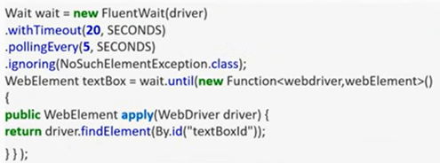

1. What are the different keyboard operations that can be performed in selenium?

Ans. The difference keyword operations that can be performed in selenium are-

* .sendKeys(“sequence of characters”) – Used for passing character sequence to an input or textbox element.
* .pressKey(“non-textkeys”) – Used for keys control, function keys etc. that are non-text.
* .releaseKey(“non-textkeys”) – Used in conjunction with keypress event to simulate releasing a key from keyboard event.

1. What are the different mouse actions that can be performed?

Ans. The different mouse events supported in selenium are –

* click(WebElement element)
* doubleClick(WebElement element)
* contextClick(WebElement element)
* moveToElement(WebElement element)
* dragAndDrop(WebElement element)

1. Write the code to double click an element in selenium?

Ans. Actions action= new Actions(driver);

WebElement element = driver.findElement(By.id(“elementId”));

action.doubleClick(element).build().perform();

1. Write the code to right click an element in selenium?

Ans. Actions action= new Actions(driver);

WebElement element = driver.findElement(By.id(“elementId”));

action.contextClick(element).build().perform();

1. How to mouse hover an element in selenium?

Ans. Actions action= new Actions(driver);

WebElement element = driver.findElement(By.id(“elementId”));

action.moveToElement(element).build().perform();

1. How to fetch the current page URL in selenium?

Ans. Using getCurrentURL() command we can fetch the current page URL.

driver.getCurrentUrl();

1. How can we fetch title of the page in selenium?

Ans. Using driver.getTitle(); we can fetch the page title in selenium. This method returns a string containing the title of the web page title.

1. How can we fetch the page source in selenium?

Ans. Using driver.getPageSource(); we can fetch the page source in selenium. This method returns a string containing the page source.

1. How to verify tooltip text using selenium?

Ans. WebElement have an attribute of type ‘title’. By fetching the value of ‘title’ attribute we can verify the tooltip text in selenium.

1. How to locate a link using its text in selenium?

Ans. Using linkText() and partialLinkText() we can locate a link.

* The difference between the two is linkText matches the complete string passed as parameter to link texts. Whereas partialLinkText matches the string parameter partially with the link texts.

WebElement link1 = driver.findElement(By.linkText(“linkTestingTool”));

WebElement link2 = driver.findElement(By.partialLinkText(“TestingTool”));

1. What are DesiredCapabilities in selenium webdriver?

Ans. Desired capabilities are a set of key-value pairs that are used for storing and configuring browser specific properties like its version, platform etc in the browser instance.

1. How can we find all the links on a web page?

Ans. All the links are of anchor tag ‘a’. So by locating elements of tagName ‘a’ we can find all the links on a webpage.

List<WebElement? Links = driver.findElements(By.tagName(“a”));

1. What are some commonly encountered exceptions in selenium?

Ans. Some of the commonly seen exception in selenium are –

* NoSuchElementException – When no element could be located from the locator provided.
* ElementNotVisbileException – When element is present in the DOM, but it is not visible.
* NoAlertVisibleException – When we try to switch to an alert, but the targeted alert is not present.
* NoSuchFrameException – When we try to switch to a frame, but the targeted frame is not present.
* NoSuchWindowException – When we try to switch to a window, but the targeted window is not present.
* TimeoutException – When a command executions get timeout.
* InvalidElementStateException – When the state of an element is not appropriated for the desired action.
* NoSuchAttributeException – When we are trying to fetch an attribute’s value but the attribute is not correct.
* WebDriverException – When there is some issue with driver instance preventing it from getting launched.

1. How can we capture screenshots?

Ans. Using getScrrenshotAs method of TakesScreenshot interface we can take the screenshot in selenium.

File srcFile = ((TakesScreenshot)driver).getScreensshotAs(OutputType.File);

FileUtils.copyFile(srcFile, new File(“D:\\testScreenshot.jpg));

1. How to handle dropdowns in selenium?

Ans. Using Select class –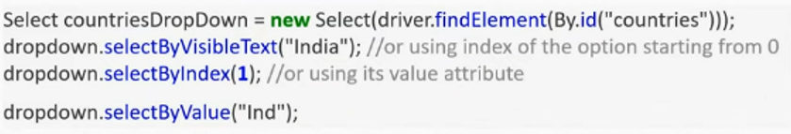

1. How to check which option in the dropdown is selected?

Ans. Using isSelected() method we can check the state of a dropdown’s option.

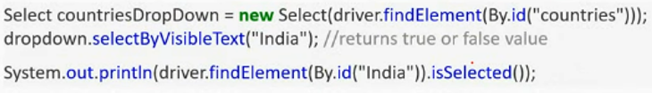

1. How can we check if an element is getting displayed on a web page?

Ans. Using isDisplayed() method we can check if an element is getting displayed or not.

driver.findElement(By locator).isDisplayed();

1. How can we check if an element is enabled for interaction on web page?

Ans. Using isEnabled() method we can check if an element is getting enabled or not.

driver.findElement(By locator).isEnabled();

1. What is the difference between driver.findElement() and driver.findElements() commands?

Ans.

findElement() returns a single WebElement (found first) based on the locator passed as parameter. Whereas finElements() returns a list of WebElements, all satisfying the locator value passed.

Syntax of findElement():

WebElement textbox = driver.findElement(By.id(“textBoxLocator”));

Syntax of findElements():

List<WebElement> elements = driver.findElements(By.id(“value”));

Another difference between two is if no elements is found then findElement() throws NoSuchElementException where as finElements() returns a list of 0 elements.

1. Explain the difference between implicit wait and explicit wait?

Ans. An implicit wait, while finding an element waits for a specified time before throwing NoSuchElementException in case element is not found. The timeout value remains valid throughout the webDriver’s instance and for all the elements.

driver.manage().timeouts().implicitlyWait(180,TimeUnits.SECONDS);

Whereas,

1. How can we handle window UI elements and window POP ups using selenium?

Ans. Selenium is used for automating Web based application only (or browsers only. For handling window GUI elements, we can use AutoIT or Sikuli.

1. What is Robot API?

Ans. Robot API is used for handling keyboard or mouse events. It is generally used to upload files to the server in selenium automations.

Robot robot = new Robot();

Robot.keyPass(KeyEvent.VK_ENTER);

1. How to do file upload in selenium?

Ans. File upload action can be performed in multiple ways –

Using element.sendKeys(“path of file”) on the webElement of input tag and type file i.e. the elements should be like.

<input type=”file” name=”fileUpload”>

Using Robot API.

Using AutoIT.

Using Sikuli.

1. How to handle HTTPS website in selenium? or how to accept the SSL untrusted connection?

Ans. Using profiles in Firefox we can handle accept the SSL untrusted connection certificate Profiles are basically set of user preference stored in a file.

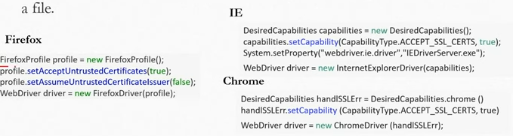

1. How to do drag and drop in selenium?

Ans. Using Action class, drag and drop can be performed in selenium. Sample code –

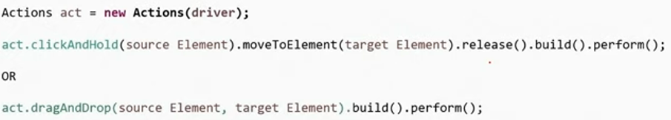

1. How to execute javascript in selenium?

Ans. JavaScript can be executed in selenium using JavaScriptExecuter. Sample code for javaScript execution –

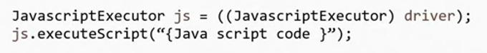

1. How to handle alerts in selenium?

Ans. In order to accept or dismiss in an alert box the alert the alert class is used. This requires first switching to the alert box and then using accept() or dismiss() command.

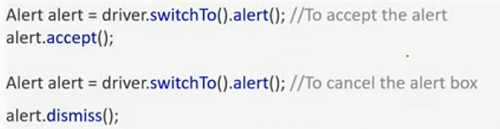

1. What is HtmlUnit Driver?

Ans. HtmlUnitDriver is the faster WebDriver. Unlike other drivers (FireFoxDriver, ChromeDriver etc.), the HtmlUnitDriver is non-GUI, while running no browser gets launched.

1. How to handle hidden elements in Selenium webDriver?

Ans. Using javaScript executor we can handle hidden elements-

* (JavascriptExecutor(driver)).executeScript(“document.getElementsBy.className(ElementLocator).click();”);

1. What is Page Object Model or POM?

Ans. Page Object Model(POM) is a design pattern in selenium.

POM helps to create a framework for maintaining selenium scripts.

* In POM for each of the application a class is created having the elements belonging to the page and methods handling the events in that page.
* The test scripts are maintained in separate files and the method of the page object files are called from the test scripts file.

1. What are the advantages of POM?

Ans. The advantages are POM are –

* Using POM we can create an Object Repository, a set of web element in separate files along with their associated functions. Thereby keeping code clean.
* For any change in UI (or web elements) only page object files are required to be updated leaving test files unchanged.
* It makes code reusable and maintainable.

1. What is Page Factory?

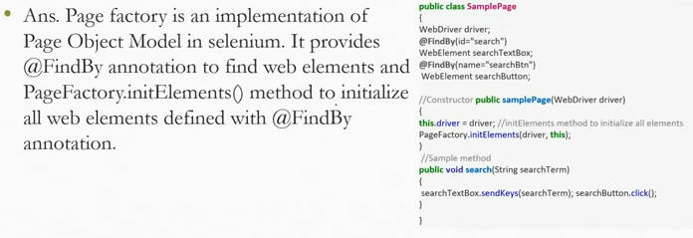

1. What is an Object repository?

Ans. An object repository is centralized location of all the objects or WebElements of the test scripts.

* In Selenium we can create object repository using Page Object Model and Page Factory design patterns.

1. What is a data driven framework?

Ans. A data driven framework is one in which the test date is put in external file like csv, excel etc. separated from test logic written in test script files. The test data drives the test cases, i.e. the test methods run for each set of test data value.

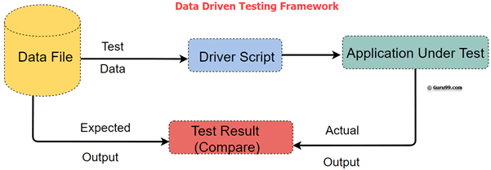

1. What is a keyword driven framework?

Ans. A keyword driven framework is one in which the actions are associated with keywords and kept in external files e.g. an action of launching a browser will be associated with keyboard – launchBrowser().

* The Code to perform the action based on a keyboard specified in external file is implemented in the framework itself.

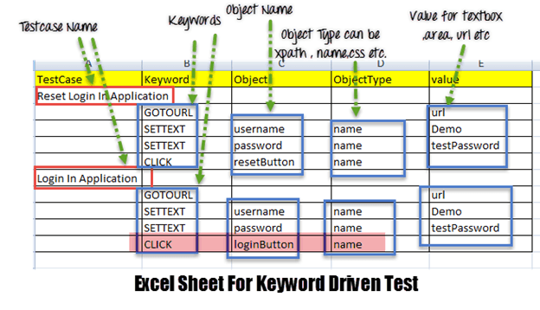

1. What is a hybrid framework?

Ans. A hybrid framework is a combination of one or more frameworks. Normally it is associated with combination of data driven and keyword driven frameworks where both the test data and test actions are kept in external files (in the form of table).

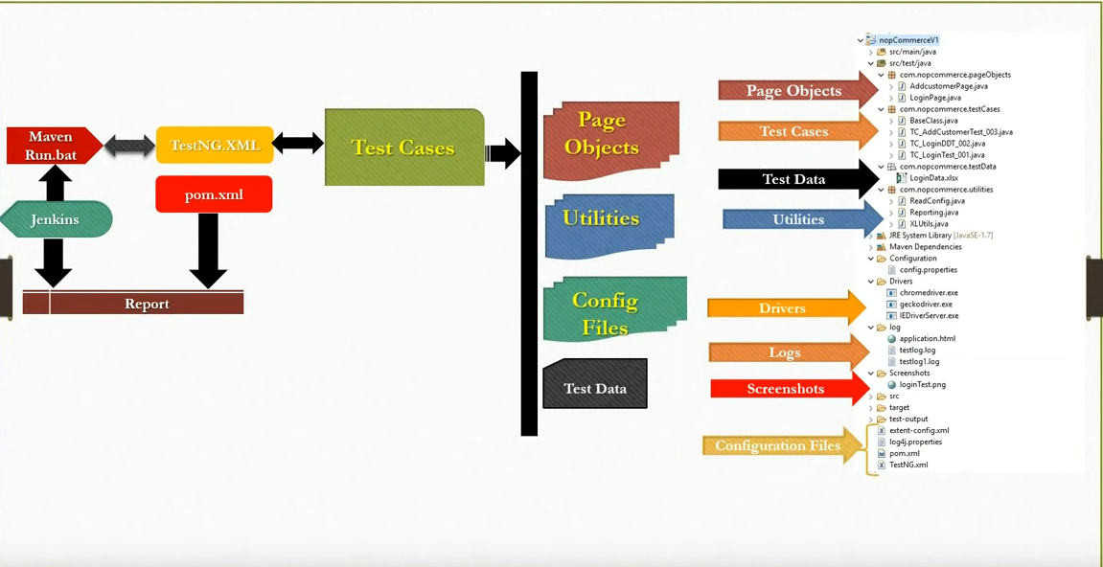

1. What is selenium Grid?

Ans. Selenium grid is a tool that helps in distributed running of test scripts across different machines having different browsers, browser version, platforms etc. in parallel. In selenium grid there is hub that is a central.

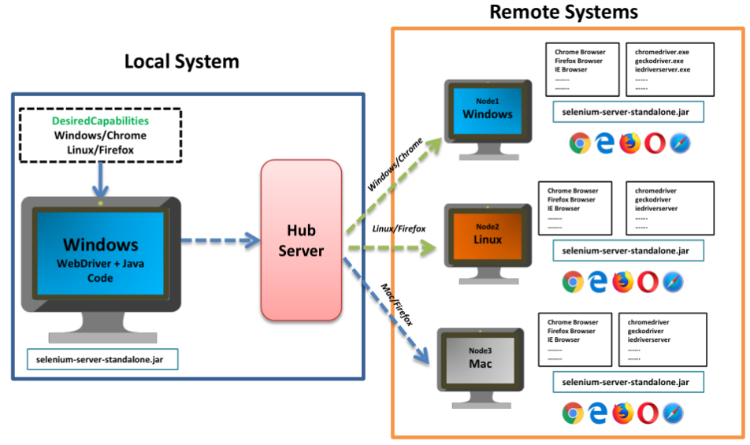

1. What are some advantages of selenium grid?

Ans.

* It allows running test cases in parallel thereby saving test execution time.
* Multi browser testing is possible using selenium grid by running the test on machines having different browsers.
* It is allowing multi-platform testing by configuring node having different operating system.

1. What is a hub in selenium grid?

Ans. A hub is server or a central point in selenium grid that controls the test execution on the different machines.

1. What is a node in selenium grid?

Ans. Nodes are the machines which are attached to the selenium grid hub and have selenium instance running the test scripts. Unlike hub there can be multiple nodes in selenium grid.

1. Explain the line of code Webdriver driver = new Firefox Driver();.

Ans. In the line of code WebDriver driver = new FirefoxDriver();

* ‘WebDriver’ is an interface and we are creating an object of type WebDriver instantiating an object of FirefoxDriver class.

1. What is the purpose of creating a reference variable driver' of type WebDriver instead of directly creating a FireFoxDriver object or any other driver’s reference in the statement WebDriver driver = new FirefoxDriver();?

Ans. By creating a reference variable of type WebDriver we can use the same variable to work with multiple browser like ChromeDriver, IEDriver etc.

1. What is testNG?

Ans. TestNG(NG for Next Generation) is a testing framework that can be integrated with selenium or any other automation tool to provide multiple capabilities like assertions, reporting, parallel test execution etc.

1. What are some advantages of testNG?

Ans. Following are the advantage of testNG:

* TestNG provides different assertions that helps in checking the expected and actual results.
* It provides parallel execution of test methods.
* We can define dependency of one test method over other in TestNG.
* We can assign priority to test method into test groups.
* It allows grouping of test method into test group.
* It allows data driven testing using @DataProvider annotation.
* It has inherent support for reporting.
* It has support for parameterization test cases using @Parameters annotation.

1. What is the use of testng.xml file?

Ans. testng.xml file is used for configuring the whole test suite.

* In testng.xml we can create test suite, create test groups, mark tests for parallel execution, add listeners and pass parameters to test scripts.
* Later this testng.xml file can be used for triggering the test suite.

1. How can we pass parameter to test script using testNG?

Ans. Using @Parameter annotation and ‘parameter’ tag in tetsng.xml we can pass parameters to the test script.

1. How can we create data driven framework using testNG?

Ans. Using @DataProvider we can create a data driven framework in which data is passed to associate test method and multiple iteration of the test runs for different test value passed from the @DataProvider method.

* The method annotated with @Dataprovider annotation returns a 2D array of object.

1. What is the use of TestNG Listeners?

Ans. TestNG provides us different kind of listeners using which we can perform some action in case an event has triggered.

* Usually testNG listeners are used for configuring reports and logging.
* One of the most widely used listeners in testNG is ITestListener interface and TestListenersAdapter Class.
* It has methods like onTestSuccess, onTestFailure, ontestSkipped, etc.
* We need to implement this interface creating a listeners’ class of our own.

1. What is the use of @Listener annotation in TestNG?

Ans. We need to implement ITestListeners interface by creating a listener class of our own.

* After that using the @Listener annotation, we can use specify that for a particular test class, our customized listener class should be used.

1. How can we make one test method dependent on other using TestNG?

Ans. Using dependsOnMethod parameter inside @Test annotation in testNG we can make one test method run only after successful execution of dependent test method.

@Test(dependsOnMethods = {“pretest”})

1. How can we set priority of test cases in TestNG?

Ans. Using priority parameter in @Test annotation in TestNG we can define priority of test cases. The default priority of test when not specified is integer value 0. Example:

@Test(priority=1)

1. What are commonly used TestNG annotations?

Ans. The commonly used TestNG annotations are –

* @Test
* @BeforeMethod
* @AfterMethod
* @BeforeClass
* @AfterClass
* @BeforeTest
* @AfterTest
* @BeforeSuite
* @AfterSuite

1. What are some common assertions provided by testNG?

Ans. Some of the common assertion provided by testNG are –

* assertEqual(String actual, String expected, String message) – (and other overloaded data type in parameters)
* assertNotEquals(double dataq, double data2, String message) - (and other overloaded data type in parameters)
* assertFalse(boolean condition, String message)
* assertTrue(boolean condition, String message)
* assertNotNull(Object object)
* fail(boolean condition, String message)
* true(String condition)

1. How can we run test cases in parallel using TestNG?

Ans. In order to run the test in parallel just add these two pairs in suite –

* parallel = “{methods/tests/classes}”
* thread-count = “{number of thread you want to run simultaneously}”
* <suite name=”paralleltesting” parallel=”tests” thread-count=”5”>

1. Name an API used for getting data from excel in Java.

Ans. Apache POI API and JXL (Java Excel API) can be used for reading, writing and updating excelfiles.

1. Name an API used for logging in Java.

Ans. Log4j is an open source API widely used for logging in Java.

* It supports multiple levels of logging like – ALL, DEBUG, INFO, WARN, ERROR, TRACE and FATAL.

1. What is the use of logging in automation?

Ans. Logging helps in debugging the tests when required also provides a storage of test’s runtime behavior.

1. What is Invocation Count in TestNG?

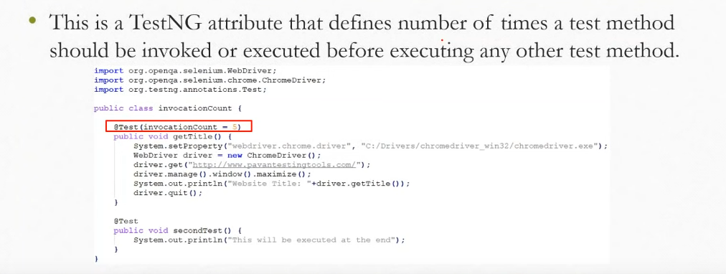

1. How can we run a Test method multiple times in a loop(without using any data provider)?

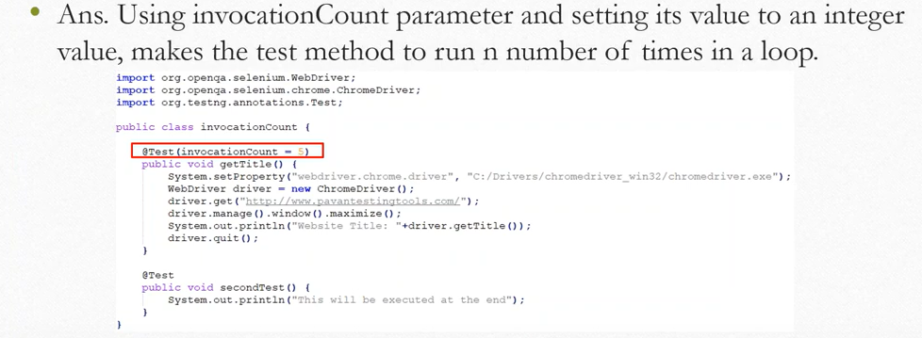

1. What is the default priority of test cases in TestNG?

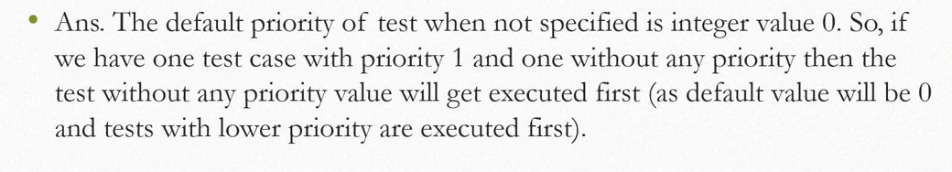

1. What is the difference between soft assertion and hard assertion in TestNG?

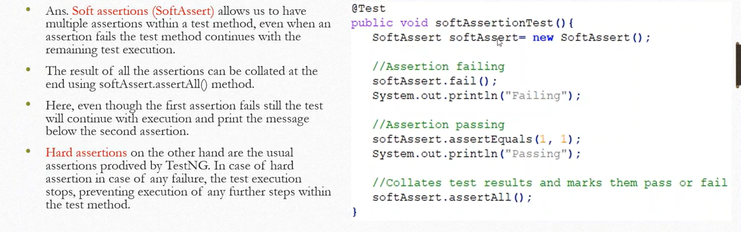

1. How to fail a testNG test if it doesn't get executed within a specified time?

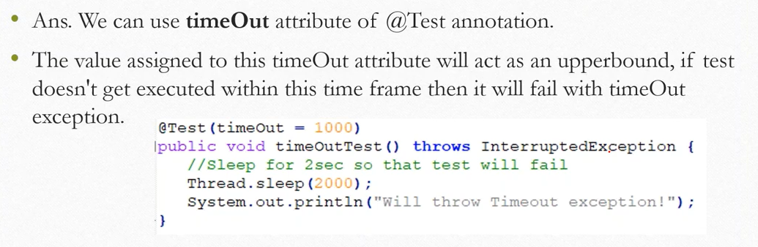

1. How can we skip a test case conditionally?

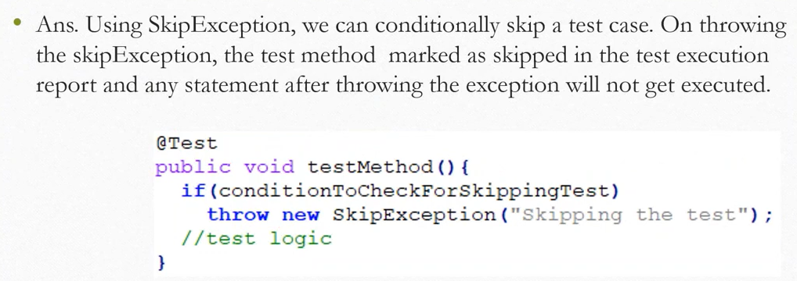

1. How can we make sure a test method runs even if the test methods or groups on which it depends fail or get skipped?

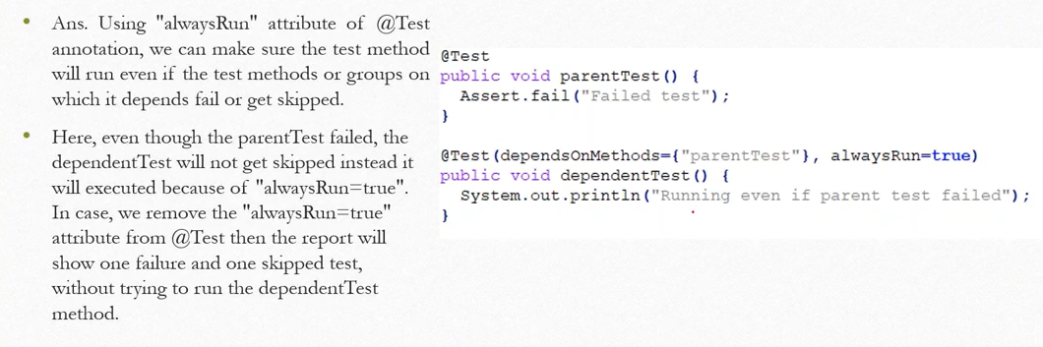

1. Why and how will you use an Excel Sheet in your project?

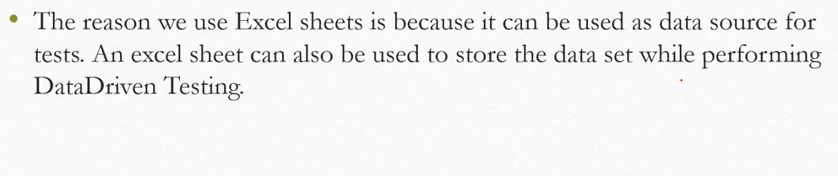

1. How can you redirect browsing from a browser through some proxy?

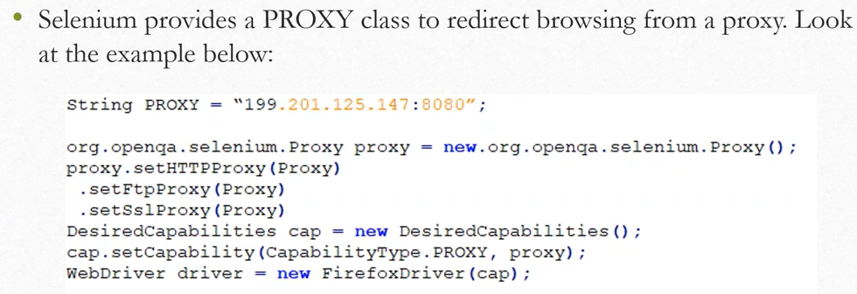

1. How to scroll down a page using javaScript in selenium?

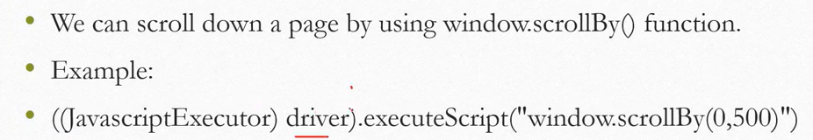

1. How to scroll down to a particular element?

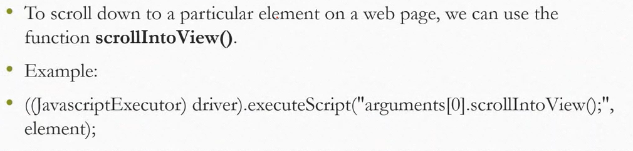

1. How to set the size of browser window using Selenium?

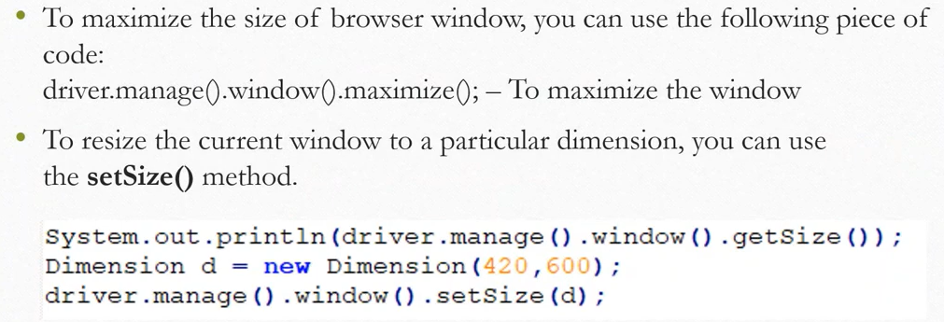

1. Can we enter text without using sendKeys()?

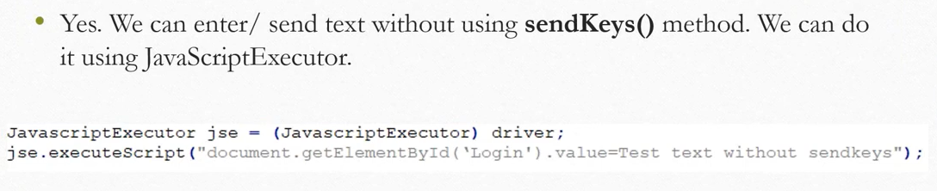

1. Explain how you will login into any site if it is showing any authentication popup for username and password?

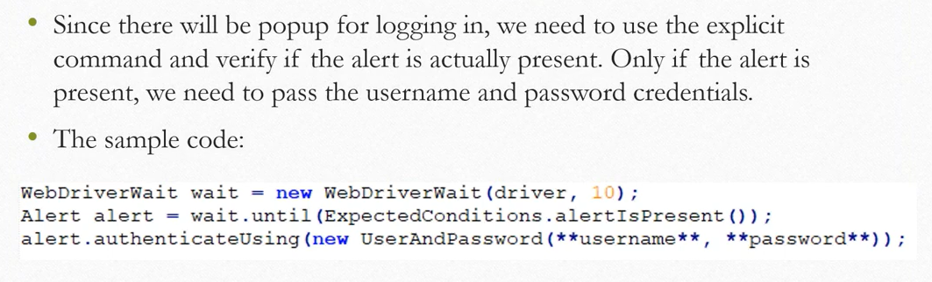

1. Explain what is Group Test in TestNG?

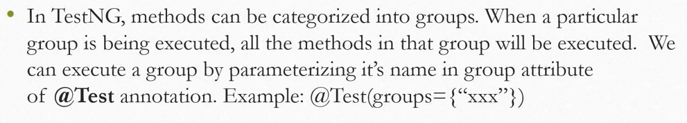

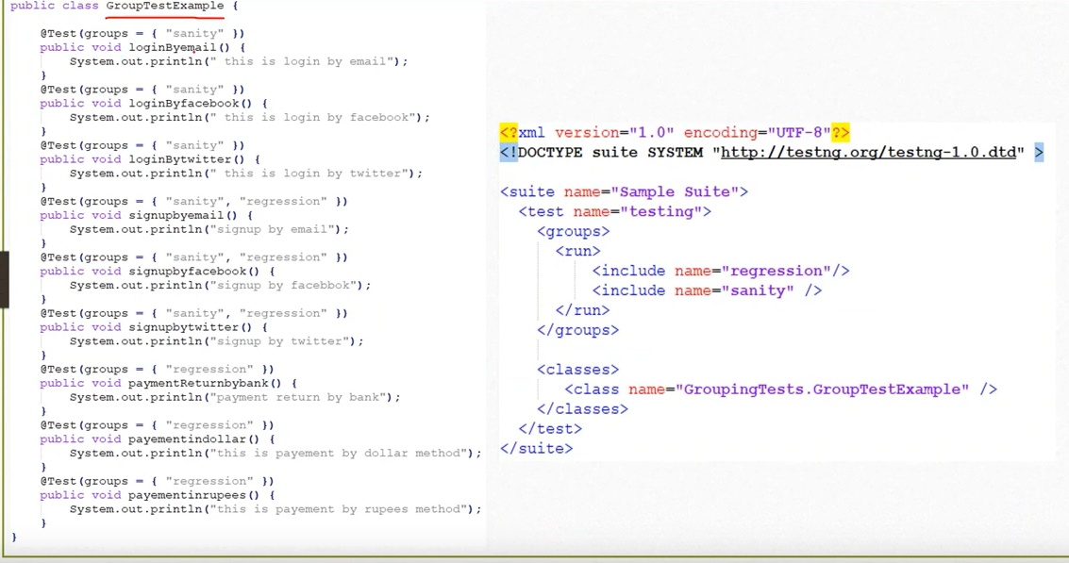

1. How To Run Failed Test Cases Using TestNG In Selenium WebDriver

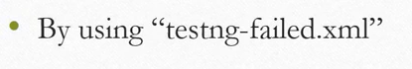

1. What is Stale Element Exception? How to handle it?

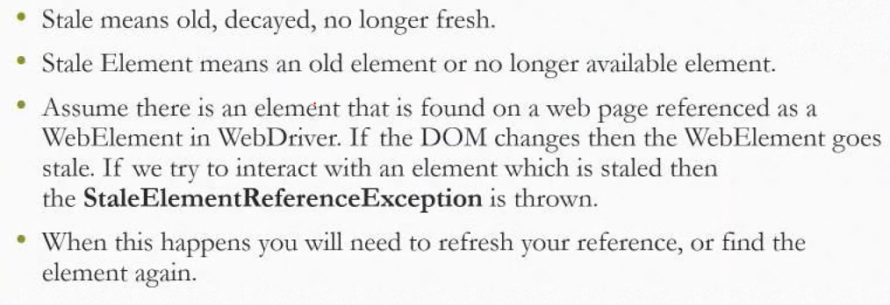

1. What are different XPath functions that you have used in your Project?

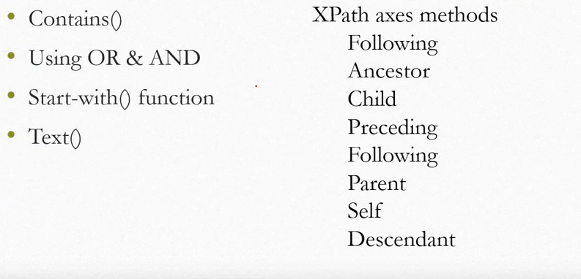

1. What will happen in background when execute new Firefox Driver?

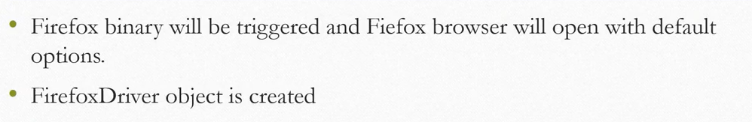

1. What is the below statement means and Why? WebDriver driver = new Firefox Drivers

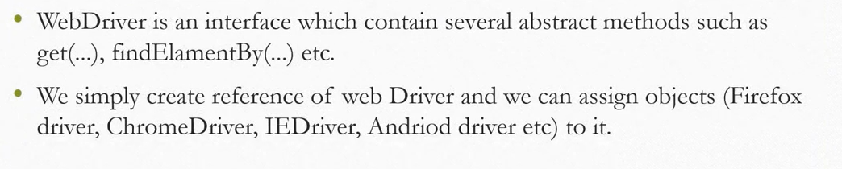

1. How do you handle inner Frames and Adjacent Frames?

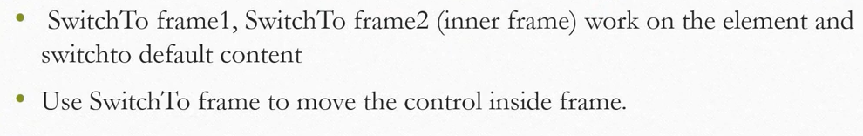

1. How to click on an element which is not visible using selenium WebDriver?

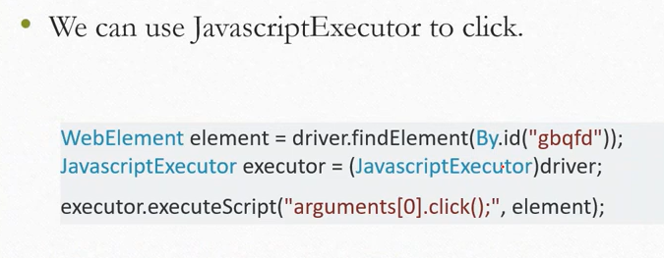

1. Difference between verify and assert.

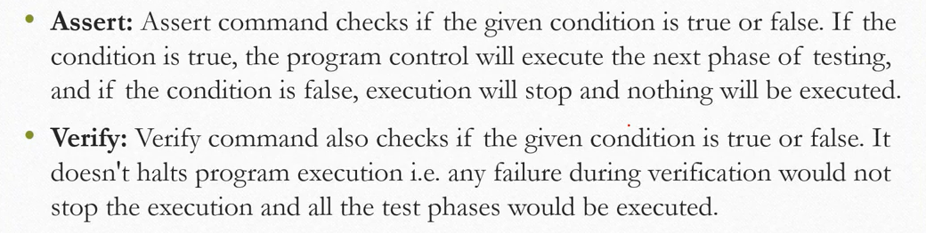

1. What is the use of @FindBy annotation?



1. Do you use Thred.Sleep?

Ans. Rarely

1. What are different pop-ups that you have handle in your projects?

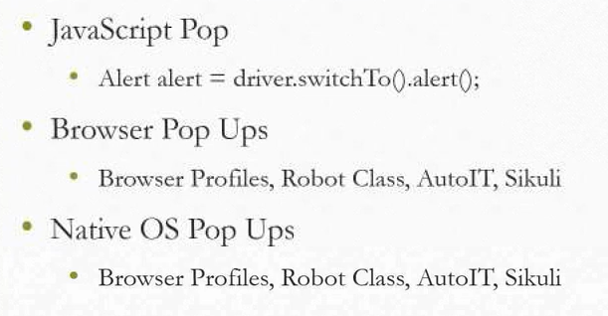

1. How do you handle HTTP Proxy Authentication pop ups in browser?

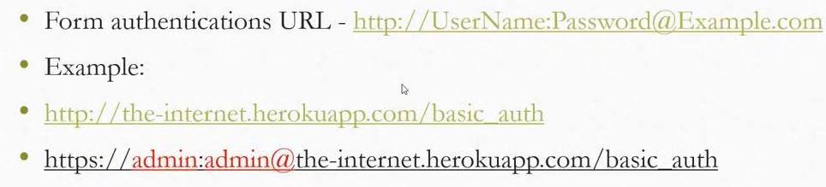

1. How do you handle Ajax dropdowns?

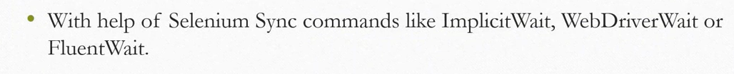

1. What is the default port for Selenium Grid?

Ans. 4444

1. How to run tests in selenium browser parallel?

Ans. Using selenium grid

1. How to find broken images in a page using selenium Web driver.

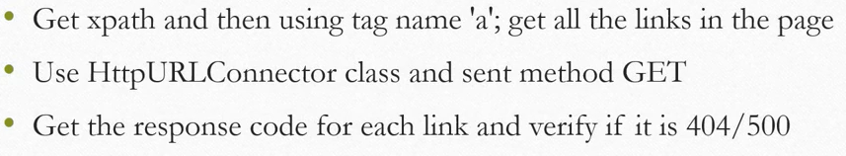

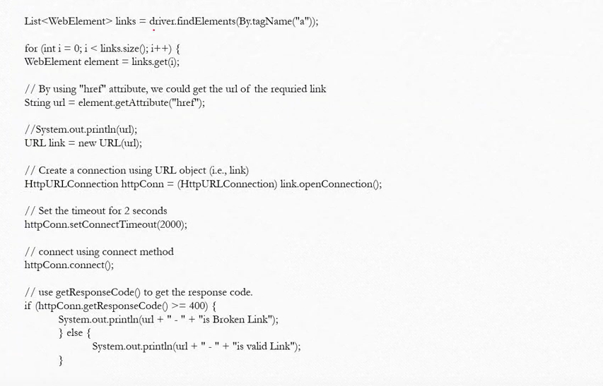

1. How does u handle dynamic elements without using XPath?

1. Write down scenarios which we can’t automate?

Ans. Barcode Reader, Captcha etc.

1. How do you manage the code versions in your project?

Ans. Using SVN, GitHub or other versioning tools.

1. How to count total no of hyperlinks in a page?

Ans. List allLinks = driver.findElements(“a”);

System.out.println(allLinks.size());

1. What are the benefits of Automation Testing?

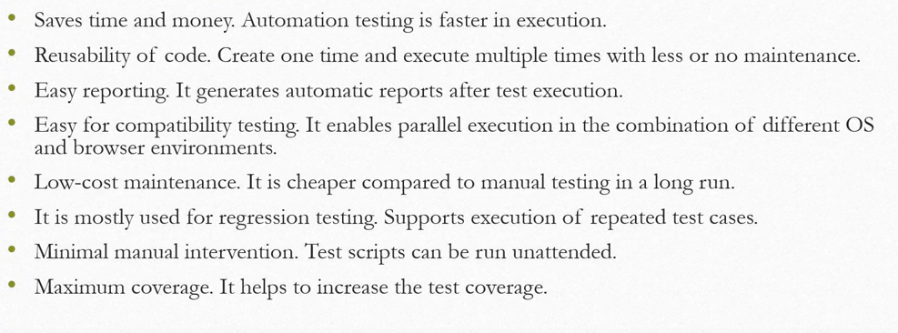

1. What type of tests have you automated?

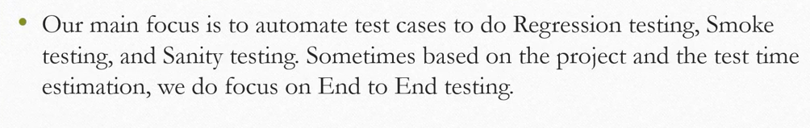

1. How many test cases you have automated per day?

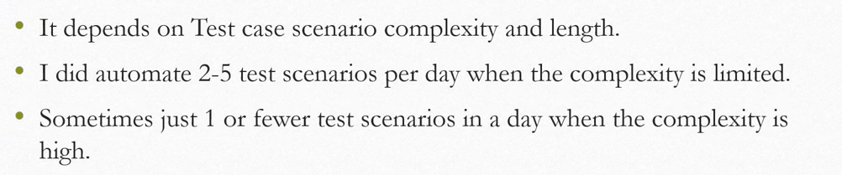

1. What is Selenium IDE?

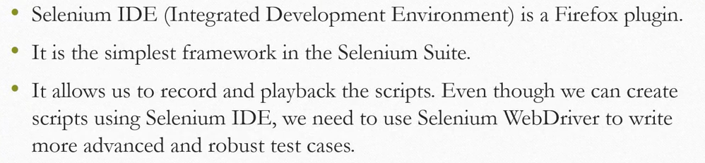

1. What is Selenese?



1. What is Selenium RC?

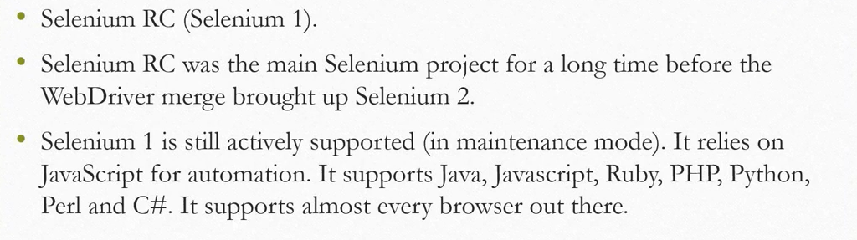

1. What is Selenium WebDriver?

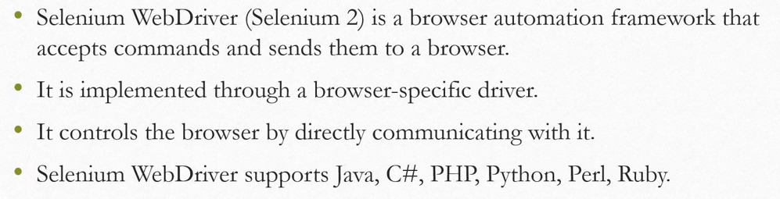

1. When do you selenium Grid?

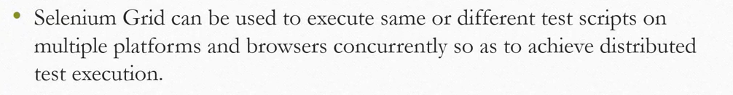

1. What are the advantages of Selenium Grid?

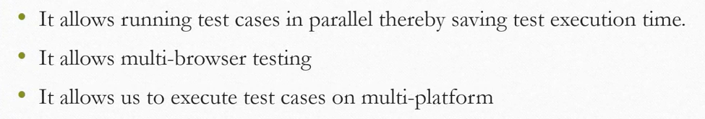

1. What is a hub in Selenium Grid?



1. What is a node in Selenium Grid?



1. Which WebDriver implementation claims to be the fastest?

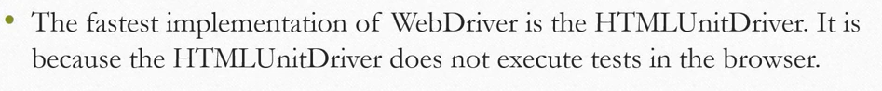

1. What are the Programming Languages supported by Selenium WebDriver?

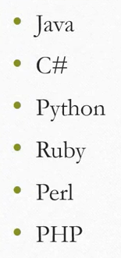

1. What are the Operating Systems supported by Selenium WebDriver?

Ans. Windows

* Linux
* Mac

1. What are the Open-source Frameworks supported by Selenium WebDriver?

Ans. Junit

* TestNG
* CUCUMBER
* JBHEAVE

1. What is the super interface of WebDriver?

Ans. SearchContext

1. What are the types of waits available in Selenium WebDriver?

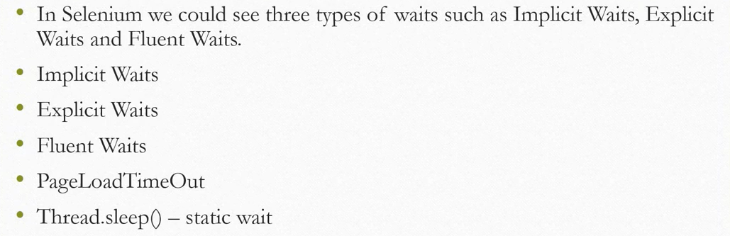

1. List some scenarios which we cannot automate using Selenium WebDriver?

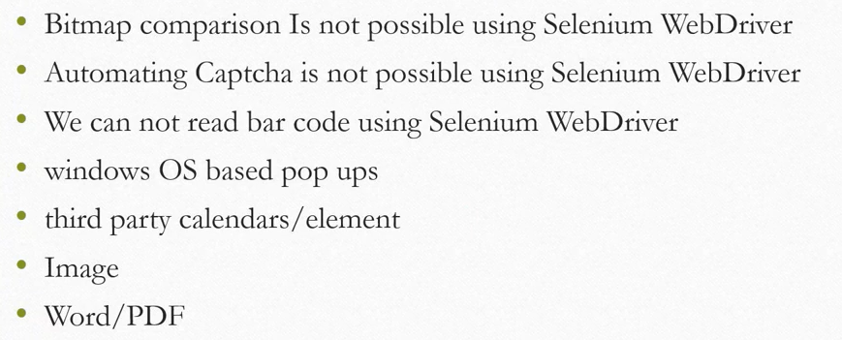

1. How can you use the Recovery Scenario in Selenium WebDriver?

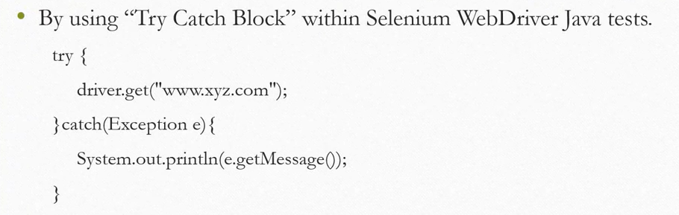

1. Database testing in Selenium?

Ans. We can use JDBC driver to connect to any database in java.

1. How to schedule the Test Suite Execution?

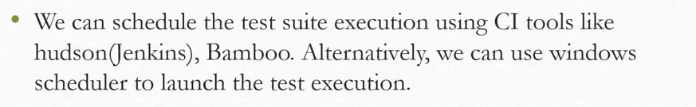

1. How to send an email stating the execution status to all stakeholders in Selenium?

Ans. We can send mail in Java using javax.mail library.

1. What us desired capabilities?

Ans. Capabilities are used to set the values of the browser attributes before we launch any browser using selenium web driver.

1. Version control tools like SVN, GIT?

Ans. We use version control tools like GitHub/SVN to track the changes to the files in a project and work in collaboration.

1. Build tools - Ant, Maven?

Ans. We use these tools to manage build activities for the java project.

1. CI tools - Jenkin, Bamboo?

Ans. These are continuous integration tools helping in quick deployment of applications, testing them and reporting the issues in the code before it is too late.

It helps in getting the application into production quickly and with more quality confidence.

1. What is a Framework?

Ans. 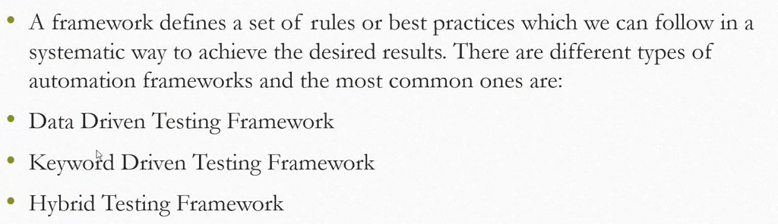

1. Have you created any Framework?

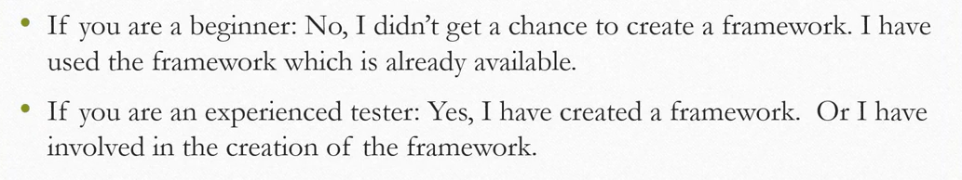

1. Can you explain the Framework which have used in your Selenium Project?

Ans. Here you have to clearly explained each component of Framework.

1. Why do you prefer Selenium Automation Tool?

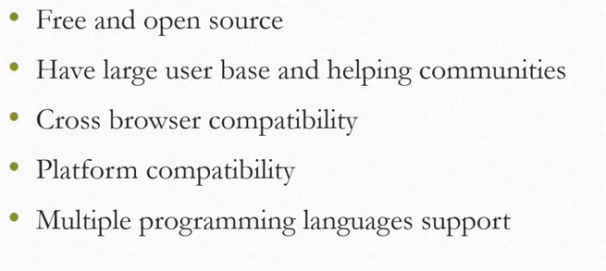

Q1. Tell me About Yourself?

Q2. Strength and Weaknesses?

Q3. CTC Explanation?

Q4. Work Experience?

Q5. Reason for Switching?

Ans. I am looking to switch for professional growth, seeking new challenges, and expending my Skill set. I believe a change will provide a fresh environment where I can contribute effectively and continue to develop my career.

Q6. Work Life Balance?

# Concepts of OOPS in Selenium Automation Framework

**ABSTRACTION**

Abstraction is the methodology of hiding the implementation of internal details and showing the functionality to the users.

Let’s see an example of data abstraction in Selenium Automation Framework.

In Page Object Model design pattern, we write locators (such as id, name, xpath etc.,) and the methods in a Page Class. We utilize these locators in tests but we can’t see the implementation of the methods. Literally we hide the implementations of the locators from the tests.

**INTERFACE**

Basic statement we all know in Selenium is WebDriver driver = new FirefoxDriver();

Detailed explanation on why we write WebDriver driver = new FirefoxDriver(); in Selenium.

WebDriver itself is an Interface. So based on the above statement WebDriver driver = new FirefoxDriver(); we are initializing Firefox browser using Selenium WebDriver. It means we are creating a reference variable (driver) of the interface (WebDriver) and creating an Object. Here WebDriver is an Interface as mentioned earlier and FirefoxDriver is a class.

An interface in Java looks similar to a class but both the interface and class are two different concepts. An interface can have methods and variables just like the class but the methods declared in interface are by default abstract. We can achieve 100% abstraction and multiple inheritance in Java with Interface.

**INHERITANCE**

The mechanism in Java by which one class acquires the properties (instance variables) and functionalities of another class is known as Inheritance.

We create a Base Class in the Automation Framework to initialize WebDriver interface, WebDriver waits, Property files, Excels, etc., in the Base Class.

We extend the Base Class in other classes such as Tests and Utility Class.

Here we extend one class (Base Class like WebDriver Interface) into other class (like Tests, Utility Class) is known as Inheritance.

**POLYMORPHISM**

Polymorphism allows us to perform a task in multiple ways.

Combination of overloading and overriding is known as Polymorphism. We will see both overloading and overriding below.

**METHOD OVERLOADING**

We use Implicit wait in Selenium. Implicit wait is an example of overloading. In Implicit wait we use different time stamps such as SECONDS, MINUTES, HOURS etc.,

Action class in TestNG is also an example of overloading.

A class having multiple methods with same name but different parameters is called Method Overloading

**METHOD OVERRIDING**

We use a method which was already implemented in another class by changing its parameters. To understand this you need to understand Overriding in Java.

Declaring a method in child class which is already present in the parent class is called Method Overriding. Examples are get and navigate methods of different drivers in Selenium.

**ENCAPSULATION**

All the classes in a framework are an example of Encapsulation. In POM classes, we declare the data members using @FindBy and initialization of data members will be done using Constructor to utilize those in methods.

Encapsulation is a mechanism of binding code and data (variables) together in a single unit.

**Other Selenium Automation Framework Concepts**

I would like to discuss some other topics which we use in Automation Framework.

**WEB** **ELEMENT**: Web element is an interface used to identify the elements in a web page.

**WEBDRIVER**: WebDriver is an interface used to launch different browsers such as Firefox, Chrome, Internet Explorer, Safari etc.,

**FIND BY:** FindBy is an annotation used in Page Object Model design pattern to identify the elements.

**FIND ELEMENT:** Find Element is a method in POM to identify the elements in a web page.